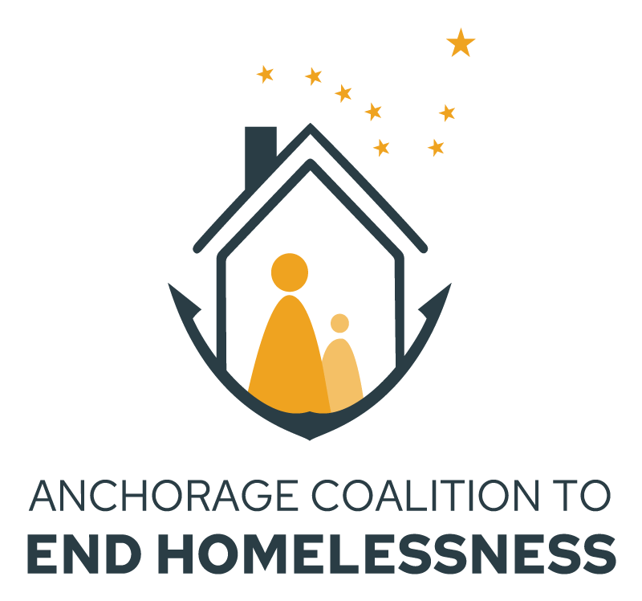

Anchorage (AK-500) FFY 2023 HUD Continuum of Care Program Local Competition
New Project, DV Bonus, and Expansion Project Application

NOFO Release Date: Wednesday, July 5, 2023
Project Application Release Date: Wednesday, August 7, 2023
Project Application Due Date: Wednesday, August 25, 2023

HUD CoC Local Competition NOFO
The Anchorage Coalition to End Homelessness (ACEH) is soliciting Local Project Applications for the Federal Fiscal Year (FFY) 2023 Continuum of Care (CoC) Program funding competition.

Application Information
!!!Use The ACEH FFY23 Nofo New Project Application Instructions!!!

Application Support
Application support will be offered via Virtual Teams Meetings
- August Sessions – Thursdays from 2 pm to 3 pm: August 10, 17 and 24
Add to Calendar
- September Sessions – Thursdays from 2 pm to 3 pm: September 7, 14 and 21
Add to Calendar
Please send all questions regarding the application process to the ACEH grants email: grants@aceh.org.

Application Deadline
FFY2023 CoC Project Application Packet is due to ACEH by Friday, August 25, 2023. If an agency is applying for more than one project, each project requires a separate project application form. For questions and application submissions, please email the ACEH grants email at: grants@aceh.org. A complete application packet will include:
- A completed New Project Application
- Verification of 25% cash or in-kind match
- Project Budget
- Local Project Submission Agreement (coming soon)

All application packets must be sent as a PDF document with subject line: “SUBMISSION: <PROJECTNAME> AK-500 CoC New Project Application”

New Applicants
There are several steps that must be completed prior to submitting a federal application for HUD CoC Funding. These steps can be time-consuming and should be completed ASAP if your agency has not previously received HUD grant funding. If your agency has received funding, it is still recommended that you review the steps and access requirements listed below.
- Register at SAM.gov – you will need to register your entity and be assigned a Unique Entity Identifier (UEI). You will not be able to submit an application in the e-snaps online portal without one.
- Set up a HUD Exchange Account – This will provide you with access to a wide variety of HUD resources, including instructions, webinars, training, regulations, requirements, best practices, and a lot of general information.
- Establish a User Profile and an Organizational Profile in e-snaps. These instructions may be helpful – everywhere the instructions mention a DUNS number, please substitute the UIE number.

FFY2023 AK-500 CoC Local Project New Application Form
APPLICATION DEADLINE: Friday, August 25, 2023

PART I: Project Information
 | AK-500 Project Applicant Information
Agency (Grant Recipient) Name:

Project Name:

Project Sub-recipient Organization Name (if applicable):

Project Address:

Check this box if this project will provide scattered-site leasing or rental assistance ☐
Contact Person(s) for Project Application
Name:  Title: |  |  | Phone Number:  Email:
Contact Information for Organization’s Executive Director
Name:  Title: |  |  | Phone Number:  Email:
Contact Person(s) for HMIS  Name:  Title: |  |  | Phone Number:  Email:
Contact Person(s) for e-snaps entry
Name:  Title: |  |  | Phone Number:  Email:
Project HUD Funding Request:
Project Grant Term Requested (can be 12 or 18 months):
Project Start Date for FY2023 CoC Grant Term (beginning in CY2024):
Application Project Type (Select One):
- Permanent Supportive Housing (PSH)
☐ Permanent Supportive Housing – Dedicated Plus (also PSH)
- Rapid Rehousing (RRH)
- Joint Transitional Housing & Rapid Re-Housing (TH/RRH)
- Supportive Services Only - Coordinated Entry (SSO-CE)
Additional Questions:
- This project is an Expansion Project (If yes, contact ACEH for detailed instructions):
Renewal Project Name this expansion is attached to:

- This project is a Transition Project (If yes, contact ACEH for detailed instructions):

Original Project Name and Type:

New Project Name and Type:

 | YES | NO
Are there any unresolved HUD monitoring or OIG audit findings for any HUD grants (including ESG) under your organization? If yes, attach the finding and a description of how it was or will be resolved. | ☐ | ☐

PART II: THRESHOLD REQUIREMENTS – Agency & Project
To be eligible for AK-500 CoC funding, the applicant organization must meet all threshold requirements. Threshold requirements and AK-500 CoC expectations can be found in the Applicant Pre-submission Agreement. Failure to meet the required thresholds or to review and commit to the entire Agreement will result in a reduction of points or a rejected application, as subject to the Rank & Review Committee. The organization must have received a written acknowledgment of the receipt of their Applicant Pre-submission Agreement from ACEH before their Local Competition Application will be forwarded to the Ranking Committee.

The first table below highlights top-level eligibility requirements and is not comprehensive. Complete agency threshold and participant eligibility requirements can be found in the NOFO beginning on page 54.

AK-500 CoC Agency & Participant Threshold Requirement |  | Agency Self-Report
 |  | Yes | No
A | Project will operate using genuine Housing First Principles and Low Barrier Implementation.
B | Agency can provide proof of a 501(c)(3) tax-exempt status or is a Tribally Designated Housing Entity or tribal entity.
C | Applicant must be registered with SAM.gov and must have a Unique Entity Identification. What is your UEI?  _________________________________________
D | Project applicant agrees to participate in the statewide AKHMIS. Victim Service providers agree to use a comparable database that meets the needs of the AKHMIS. Reports from these system will allow for project performance evaluations as outlined in HUD System Performance Measures (SPMs).
E | People being served by the project must meet the HUD definitions 1, 2 or 4 of homelessness and live in the geography defined as the Anchorage area (everywhere between Chugiak and Girdwood). The project applicant must be able to establish the eligibility of project participants upon request.
F | Has your organization previously received federal grant funding?
G | The Agency acknowledges that the Review & Rank committee and HUD will consider an applicant’s past performance in managing federal funds, including, but not limited to:  - reporting and recordkeeping requirements  - timely use of funds received  - timely submission and quality of reports  - meet program requirements  - meet performance targets as set in grant agreements  - capacity, staffing structure, and capabilities  - timely completion of activities  - receipt and expenditure of promised matching funds  - number of persons served  - promotion of self-sufficiency & economic independence  - produce positive outcomes and results

Projects must meet or exceed minimum scoring requirements to be considered for funding. Complete project-type criteria can be found in the NOFO beginning on page 55.

You must verify that you have reviewed the agency and applicable project-type requirements and criteria for this new project application and affirm that both your organization and this project meet them.

 |  | YES | NO
A | I have reviewed the agency threshold requirements and affirm that our organization meets them.
B | I have reviewed the project threshold requirements and affirm that our project meets them. The project type is:____________________

Check this box for Planning Project Application (only for ACEH)

PART III: PROJECT FOCUS AND COC BED COUNTS
THROUGHOUT THIS APPLICATION, BOXES WITH BLUE SHADING ARE NOT MEANT FOR DATA ENTRY. ONLY PUT YOUR ANSWERS IN BOXES WITH NO SHADING!

Is this project limited to only serving households that have experienced or are actively fleeing domestic violence, dating violence, sexual assault, stalking, or other dangerous or life-threatening conditions (including human trafficking)? ______YES ______ NO

 |  |  |  | YES |  |  | NO
1. | Does this project serve families?
 | a | How many total beds (not units) are included in the project?
 | b | Which of the following populations are served using these project beds?
 |  | Chronically Homeless Families
 |  | Veteran Families
 |  | Domestic Violence (DV) Families
 |  | Parenting Youth (24 or younger)
 | c | Of the total number of beds how many beds (not units) are CoC grant-funded?
 | d | Are the populations served with CoC-funded beds different than the ones indicated above? If yes, please explain:
2 | Does this project serve individuals, instead of or in addition to families?
 | a | How many total beds (not units) are included in this project?
 | b | Which of the following populations are served using these project beds?
 |  | Chronically Homeless Individuals
 |  | Veteran Individuals
 |  | Domestic Violence (DV) Individuals
 |  | Unaccompanied Youth (24 or younger)
 | c | How many beds (not units) are CoC grant-funded?
 | d | Are the populations served with the CoC-funded beds different than those indicated above? If yes, please explain:

PART IV: Project Alignment with Community Need

Objectives |  | Yes No
A | Project is located in a community that has no other CoC-funded projects

Coordination with Healthcare and other Housing Resources |  | Yes No
B | Project utilizes housing subsidies or subsidized housing units not funded through the CoC or ESG programs. These housing units, which are not CoC or ESG funded, may be funded by any of the following: private organizations, State or local government, Public Housing Agencies, Faith Based organizations, or Federal Programs other than CoC. Resource must be equivalent to 25% of CoC Grant and documentation is required.
C | Project utilizes healthcare resources to help individuals and families experiencing homelessness. This must include at least one of the following: provide access to treatment or recovery services for all participants who qualify and choose those services, provision of healthcare services by a private or public organization tailored to the program participants, or a financial contribution from a public or private healthcare agency or health insurance provider. Resource must be equivalent to 25% of CoC Grant and documentation is required.

PART V: Financials
**Please review the New Project, DV Bonus, and Expansion Project
Application Instructions & Guidelines for examples, explanations, and links regarding the budget line-item categories below**

A. CoC Funding Request
Proposed FY Project Budget: please note that “Match” funds must be at least 25% of the proposed project budget; additional funds are “leverage”. Project income may be included under “Match” or “Leverage”. In addition to completing the tables below, please attach a copy of your anticipated budget for this project.

HUD Requested Budget for Project
Newly approved VAWA expenses | $
Newly approved Rural expenses | $
Operations | $
Building Lease | $
Rental Assistance | $
Supportive Services | $
HMIS | $
Administrative | $
TOTAL | $
MATCH | $
LEVERAGE | $
PERCENT of Match + Leverage

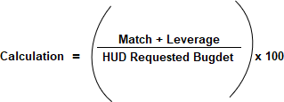

B. Match & Leverage Details
Provide detail of the total “Match” and “Leverage” indicated in PART V.B

Grant or Source Name | Amount | Pending / Confirmed | Cash / In- Kind | Direct / Indirect Costs | Use of funding | Match / Leverage / Medicaid
Add additional rows, as necessary.

PART VI: CoC Coordinated Entry Participation
 |  | YES | NO
1A | Agency will participate in Anchorage Coordinated Entry (CE), including participating in data-sharing and case conferencing, and receiving 100% of referrals from the Community-wide Prioritization List.
1B | Agency will actively engage with outreach to identify referred clients and will provide application assistance.

Indicate your organization’s existing level of Coordinated Entry participation by checking all boxes that apply. If your organization has had no interaction with the CE process prior to the project this application is for, please check this box. ☐

What is your referral region? ______________________________
 |  | YES | NO
2A | Use the CoC common assessment tool which can be found here
2B | Participate in case conferencing in your referral zone
2C | Receive referrals from the local CE community-wide prioritization list  Number of referrals you’ve accepted since 1/1/23.

PART VII: Utilization of Housing First Principles and Practice
Project applicant certifies that this is a low barrier project and that it operates in adherence with Housing First requirements.

 | Housing First Utilization | Yes | No
A | Project certifies that it will be low barrier and will adhere to Housing First requirements

PART VIII: Agency & Project Narrative Questions

- Project description:
a. Describe your project
b. How will it benefit the Homeless Prevention and Response System, and
c. How will it fit within the HUD priorities for the FFY23 NOFO.

- Description of the services provided to clients and the partners involved in the project:
a. Which services will be provided through the project,
b. How often will the service be offered (such as daily, weekly, monthly, as needed), and
c. Which partner agencies/organizations will be involved in providing services.
a. Service | b. Frequency | c. Partners
Case management
Transportation
ID/Birth Certificate/SSN
SSI/SSDI application assistance
Medicare/Medicaid application assistance
Connection to mainstream supports (TANF, SNAP)
Mental health services

Substance use/misuse treatment
Physical health, primary care provider
Educational supports
Workforce training
Employment supports
Regional shareholder services
Follow-up/check-in

- Describe the project’s connection to and leveraging of the following resources: .
a. Philanthropic or local funding sources,
b. Integration of healthcare resources within the project and connecting clients to healthcare (attach MOU in your application packet).

- Provide a summary of measurable performance goals for the first year of implementation for this project, such as
a. the number of clients to be served,
b. increases to income/benefits,
c. connections to other resources such as employment, job training, beneficiary services, transportation, etc.
d. Will you have a staff member helping clients who has been SOAR trained in the last 24 months or will be trained in the next 9 months?

- How is your organization addressing equity and inclusion for underserved communities, including
a. Black, Indigenous, and people of color,
b. Members of the LGBTQ2S+ community, and
c. People with disabilities?
d. How will you incorporate the feedback of those with lived expertise?

- Has your organization ensured that under-represented individuals (BIPOC, LGBTQ2S+, etc) are represented in the capacities listed below? If so, what actions have been taken prior to this funding competition? If not, what plans have been made to ensure equitable representation in the future?
a. Staff
b. Management
c. Decision-making positions/Board or Advisory Committee

PART IX: Local Application Certification
On behalf of the agency, I certify that I am authorized to affirm the responses in this application form and that the responses are all truthful to the best of my knowledge.

Name:

Electronic signature authorization (please check box): ☐
I agree that this box is the legal equivalent of my manual signature on this agreement.

Title:
Date:

